COS30043 Interface Design and Development
Lab 01 — Submission Notes
Name: ________Lynn Myat Bhone Htut______________________ Student ID: ___________105973835___________

1. Files in this submission
File submitted | What it is
lab01-website.zip | Part 2 — website source code (index.html, styles.css, images/)
lighthouse-score.png | Part 3 — Lighthouse accessibility score for my website

2. Part 2 — Website
The website is a single page built with HTML and an external CSS stylesheet. It contains all required elements:
- Logo — inline SVG in the header, also used as the favicon
- Page title — the <title> element and the page's <h1>
- Navigation bar — five links to sections of the page
- Footer — address, phone, email, opening hours and copyright
- Paragraph, image, table and list — in the main body, plus an order form
Accessibility was considered while building rather than patched afterwards: semantic landmarks (header, nav, main, footer), a skip link, alt text on the image, a table caption with scoped headers, visible keyboard focus outlines, and colour combinations checked against the WCAG AA contrast ratio of 4.5:1.

3. Part 3 — Lighthouse audit
Audit run in Chrome DevTools on the page served by VS Code Live Server, with only the Accessibility category selected.
Accessibility score: ___100_____ / 100
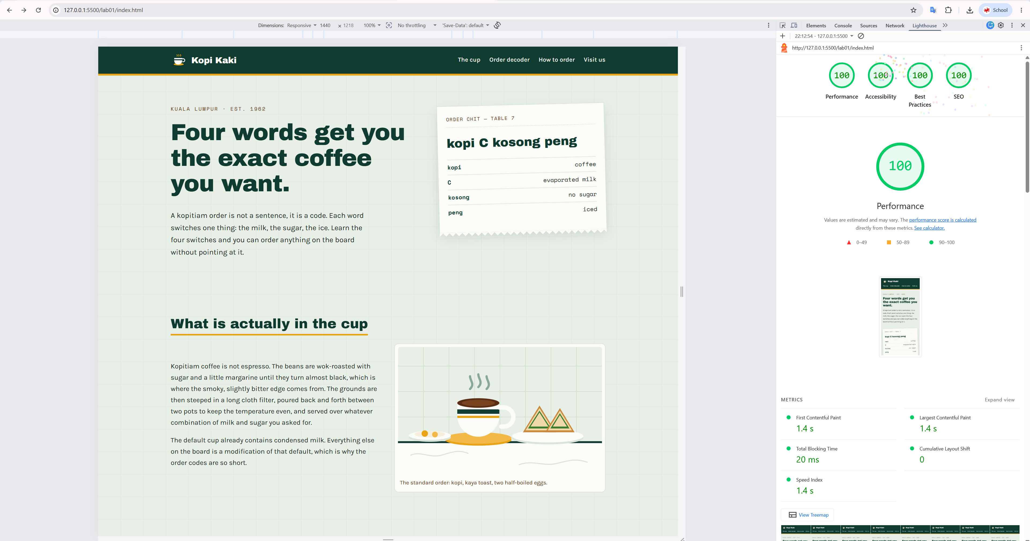

4. Note on the AChecker tool
The AChecker address given in the lab sheet, achecker.achecks.ca/checker/index.php, was not reachable at the time of submission. Its replacement at achecks.org returned a server error, and the successor site achecker.ca accepts only a public page URL, so it cannot evaluate a local file.
I therefore used URL instead, which performs the same category of automated WCAG evaluation and can assess a locally stored file. Screenshots of both the unavailable AChecker page and the substitute reports are included in this submission.
